Digital Assignment #5
1945-Present

Part One: Some important Vocabulary
Term | Definition with dates | Image
Marshall Plan | It refers to an American initiative created in 1948 having the objective of providing foreign assistance to Western Europe. | 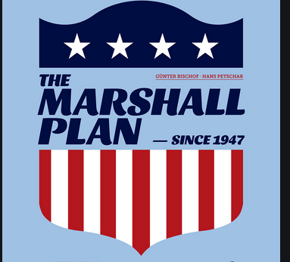
McCarthyism | It is the practice of abusing power with the intent of framing others as communists which was deployed between 1950 and 1954. | 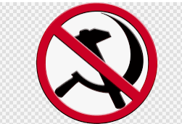
Cuban Missile Crisis | This was a one month and four days of conflict between the US and the Soviet Union started by Soviet airborne deployment in Cuba from 16th 1962 October to 28th 1962. | 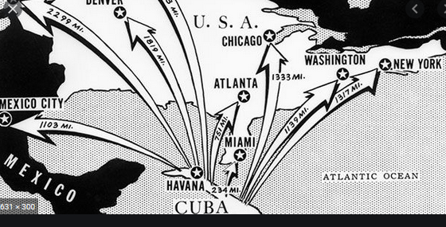
Thurgood Marshall | He was a lawyer of the Unites States as well as a civil rights activist who worked as Associate Justice of the Supreme Court of the US from October 1967 to October 1967. | 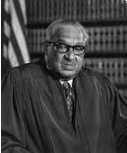
The G.I. Bill | It refers to a law offered various benefits for returning Second World War veterans that was signed in 1944. | 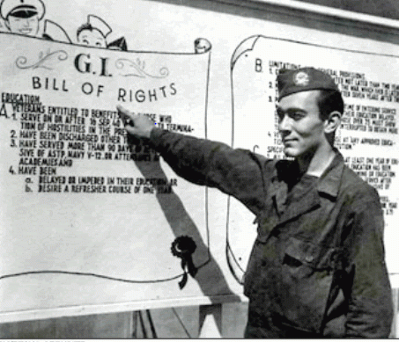
The Civil Rights Act  of 1964 | This refers to a landmark civil rights as well as labor law in the US that prohibits discrimination on grounds of race, religion, age, ethnicity, sexual orientation, gender identity and national origin created in 1964. | 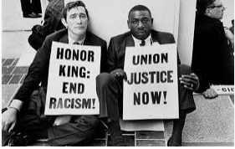
The Watergate Incident (Nixon) | It was a political scandal that happened in America linking Richard Nixon’s administration to burglary with the aim of manipulating data to aid his re-election. It happened between 1972 and 1974. | 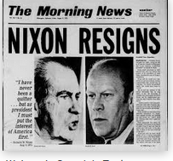
Brown v. Board of Education Court Decision | This was a case whereby the Supreme Court ruled against racial segregation in 1954. | 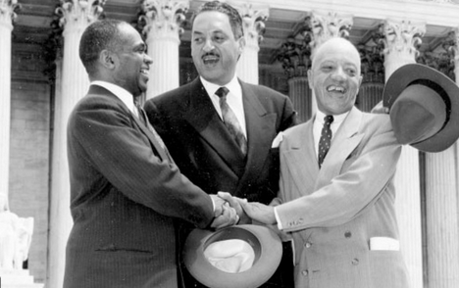
Mendez v. Westminster court case | It was the first case that took place in 1947 to state that school segregation was unlawful and violated the 14th Amendment. | 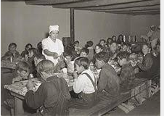
Part Two: Black Liberation Movement. Compare and Contrast. For each of the following, please describe motives, objectives, belief systems, and goals. Include at least one image in each of the three columns.
Malcolm X | Black Panther Party | Second Reconstruction
Goal  He was an ardent supporter of black nationalism  Belief system  It encapsulated both Islam and black nationalism  Motives  He strived to end racial discrimination against blacks | Goal  The party advocated for full employment, proper housing, exemption of blacks from military and end of police brutality  Belief system  It encouraged the use of violence launched against whites  Motives  Championed the rights of blacks by ensuring that they were not racially abused in America | Goal  This was a period after the Second World War when America started correcting civil and human rights abuses that was been noticed in society.  Belief system  It sought to end racial injustices through advocacy in American society  Motives  It sought to correct human and civil rights abuses in America
Part 3: Social movements. For each of the following, please elaborate on why it was important, what idea(s) it brought to light, and what change it effected, if any. Be detailed! Give dates, key figures, etc.
Woodstock | Woodstock was an important opportunity that aimed at promoting peace and harmony among people during the Vietnam War in 1969. | It had the idea of spreading peace and unity among people by ensuring they escaped into music.
Johnson’s Great Society | It had the goal of eliminating poverty and racial stereotypes in the country. | It was referenced by President Lyndon B. Johnson during his speech in 1964 at the University of Michigan (Johnson, 2015).
Civil Rights Act of 1964 | This was a landmark civil rights and labor law in 1964 that sought to end racial injustices against the minority groups in America | It had the goal of eliminating the racial injustices that the minority groups were
Stonewall Riots | The riots were started by Marsha P. Johnson who was an American gay liberation activist and the goal of the protest was for liberation of gays and LGBT rights in the US. | The riots took place on June 28th to July 3, 1969.
The Women’s Liberation Movement | Women’s liberation movement significantly shaped how women were regarded in society by raising awareness regarding their issues like political roles (Schulz, 2017). | It took place during between 1960s and 1980s and had the goals of promoting equality for women.
Roe v. Wade | The case had the significance of recognizing the constitutional right to privacy is “broad enough to encompass a woman’s decision whether or not to terminate her pregnancy.” | It was a ruling by the US Supreme Court in 1973 that allowed abortion of pregnancy
Part 4: Recent Presidential Platforms. For each of the following, please indicate that President’s official platforms on a wide variety of issues. What were their accomplishments? Failures? Legacies? Etc. Include a picture of each and the years of their presidential tenure. This should be a hefty part of the assignment, so be complete!
Jimmy Carter | Accomplishments  Jimmy Carter’s administration created a national energy policy that encompassed price control, conservation as well as new technology. Also, he pursued the Camp David Accords and the Panama Canal Treaties in foreign affairs.  Failures  US experienced energy crisis in 1979 and was followed by recession in 1980. Due to poor relations with Congress Carter was unsuccessful in the reformation of the welfare, healthcare as well as tax systems of the US.  Legacies  He formed the Carter Center that championed the promotion and expansion of human rights. Also, he was extensively involved in conducting peace negotiations and election monitoring in developing countries. | 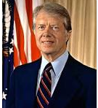  Presidential Tenure: January 20, 1977 – January 20, 1981
Ronald Reagan | Accomplishments  He enacted cuts in domestic discretionary spending, reduced taxes and escalated military spending, thereby increasing the federal debt.  Failures  He failed by signing the Iran-Contra Affair whereby arms were exchanged for hostages and the proceeds provided to the contras in Nicaragua. Besides, he encouraged the Israel invasion and sent in the marines with inadequate forces.  Legacy  He is remembered for championing the modern-day conservatism. | 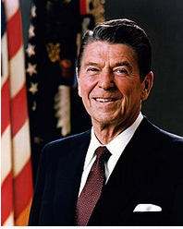  Presidential Tenure: January 20, 1981 – January 20, 1989
George H. W. Bush | Accomplishments  He succeeded in pushing for the reunification of Germany after the Fall of the Berlin Wall. Also, he spearheaded an international alliance of countries that coerced Iraq to withdraw from Kuwait in the Gulf War.  Failures  Bush faced criticism for being considered an advocate of racism. His presidential campaign was associated with the name Willie Horton.  Legacy  George H. W. Bush is remembered for his victory over Iraq after Kuwait’s invasion. | 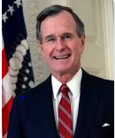  January 20, 1989 – January 20, 1993
Bill Clinton | Accomplishments  His administration led to the establishment of numerous new regimes such as the NAFTA, Free Trade and GATT (Greenstein, 2019).  Failures  Clinton’s administration was unable to appropriately redefine the US foreign following Cold War. He failed to create a comprehensive doctrine that would guide America into the 21st century.  Legacy  Bill Clinton successfully intervened in the Balkans thereby ending the conflict that threatened the security of Europe as well as the sustainability of transatlantic cooperative provisions. | 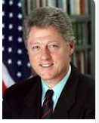  Presidential Tenure: January 20, 1993 – January 20, 2001
George Bush | Accomplishments  Bush created the United States Department of Homeland Security in response to the September 11 terrorist attack.  Failures  Bush’s administration had various failures. Firstly, his administration was marred with politicization of the Department of Justice. Secondly, there was no sustained alternative energy policy.  Legacy  Bush’s administration will be remembered for implementing robust counterterrorism policies that combated the occurring of other terrorist attacks after 9/11 bombing. | 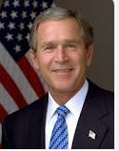  Presidential Tenure: January 20, 2001 – January 20, 2009
Barack Obama | Achievement  He increased the use of renewable energy such as solar energy  Failures  He never found the solution of curbing war in Syria. Obama’s administration did not realize the goal of ensuring that Syria was free from wars and conflicts.  Legacy  During his tenure, the stock market tripled. | 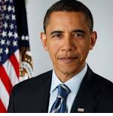  Presidential Tenure: January 20, 2009 – January 20, 2017
Part 5: As you prepare to take your role in the world, please consider what you believe will be the three most important issues Americans will have to face in the year 2050. Write an Op-Ed (opinion editorial) piece for a newspaper in which you address these issues and how you believe American (a) political leaders, (b) historians, or (c) court justices should address these. Keep SPRITE in mind (using as many of them as you can). Your piece MUST be between 750 and 1,000 words.
Citizens of America are barely hopeful regarding the future of the country in 2050. However, they are more pessimistic on particular issues such as the US economy's strength, income equality, and the future of race relations. The three issues that the country is likely to face in 30 years are diverse. Foremost, I envision that the US's economy will be weaker in 2050 than it is currently. This is because the country shall have accumulated substantial amounts of debts, which will immeasurably affect its economy. The federal government is likely to borrow more money, thereby increasing the country’s national debt. For instance, the public is pessimistic regarding the future course of the national debt. Approximately six individuals in ten believe that the national debt will increase. Political leaders will play crucial roles in ensuring that the country’s economy does not weaken. Economic growth and political stability are interlinked. Whether Republicans or Democrats, political leaders must agree together to engender an environment that will improve the country’s economy. Foremost, they have to pass laws and policies that increase innovation investment. This will enhance the creation of businesses, thereby spearheading economic growth. Political leaders need to propose laws that prevent the country from borrowing high amounts of money. They can propose a debt limit that will deter the country from accumulating high national debts. This will prevent the United States from the national debt it will incur in the long-term as a legislative limit tailoring borrowing has been enforced.
The second issue that will face Americans in the next thirty years is increased income inequality and a growing lower class. Over the next thirty years, about three-quarters of all Americans expect the disparity between the rich and the poor to widen. With many corporations embracing monopolization, many people will lose their jobs soon. Currently, reputable corporate behemoths are merging, and many employees are likely to lose their jobs. The outcome is that the rich will continue amassing wealth while the poor will have limited resources. With the rising cost of essentials like healthcare, food, and housing, the poor will be significantly affected.
However, history can help guide the present. Historians can unravel the various instances when the US economy was plagued and subdued. Also, through the different events that immensely hampered the country’s economy, vital lessons can be drawn from them to resolve income inequality issues. From the Great Depression to the Great Recession, history presents that the American economy was grossly decimated. However, historians can provide the government with detailed accounts of events that saw the country overcome increased income inequality periods. Historians can fully attest that government policies substantially tilt the balance of economic compensation between the wealthy and the poor. The insights of historians explain that both the rich and the poor can be proportionately favored to ensure that the expanding income inequality between them is reduced.
Besides, the race relations between the majority groups and minorities will worsen in the next thirty years. Even though increased advocacy and public awareness are being raised about inclusivity, I presume racism to worsen. This is because there are no stringent measures that have been put in place to deter individuals from racial discriminating against others. Currently, racial discrimination is an issue that the United States grapple with. But it has proven to be a menace whose implications have potentially long-term devastating effects. An example is it will brew hate between members of different races such as blacks and whites.
Court justices can eradicate racism by stipulating laws with punitive measures on those guilty of racially abusing others. Racism is an activity that has no place in society. Hence the court justices are critical in enacting laws that forbid racial stereotypes within the United States. The US constitution mandates courts to guarantee a fair trial and pronounce whether individuals are guilty of racial discrimination or not. This will be important in ensuring that Americans recognize the need to embrace inclusivity by denouncing racism.
Many Americans are hardly hopeful concerning the future of America in 2050. This pessimism has been inspired by the current governance system that has not done better to resolve the issues. For instance, the gap between the rich and the poor is widening, and the government has made little effort to prevent it. Nonetheless, political leaders, historians, and court justices have significant roles to play in order to ensure that the aforementioned specific issues are resolved. With concerted efforts, they can improve the making of policies within America which will enhance the various issues that may worsen in the next thirty years.

References
Greenstein, F. I. (2019). Political style and political leadership: The case of Bill Clinton. In The Clinton Presidency (pp. 137-147). Routledge.
Johnson, L. B. (2015). The great society. American History, 102(1), 100-112.
Schulz, K. (Ed.). (2017). The Women's Liberation Movement: Impacts and Outcomes (Vol. 22). Berghahn Books.

